**“Vistra financial Serv”**

**Stakeholders**

1. **Customers/Users:**
   * Existing ABC Bank account holders
   * Potential new customers
2. **Bank Management:**
   * Executives and decision-makers
3. **IT Department:**
   * Developers and technical support teams
4. **Regulatory Authorities:**
   * Compliance officers ensuring adherence to banking regulations
5. **Marketing Team:**
   * Responsible for promoting the new online FD feature
6. **Customer Support:**
   * Addresses user queries and concerns
7. **Business Analysts (Internal):**
   * Involved in gathering and analysing requirements
8. **External Auditors:**
   * Ensure the system complies with auditing standards

**As-Is and Future Process Map**

**As-Is Map**

**Future Process Map**

**Scope of Online FD Creation**

**In-Scope Features:**

User Authentication:

* Implement a secure authentication process to verify users accessing the online FD creation system through their existing online or mobile banking accounts.

FD Rate Display:

* Develop a user-friendly interface that displays applicable fixed deposit rates based on selected tenors and amounts, as outlined in the provided rate matrix.

FD Calculator

* Create an accurate and reliable FD calculator that allows users to input their age and desired FD amount, providing an instant projection of the maturity amount.

Account Selection:

* Enable users to select the source account from which the fixed deposit amount will be debited, allowing flexibility for customers with multiple bank accounts.

Maturity Instructions:

* Implement a feature that allows users to choose between renewing the FD for the same tenor or crediting the maturity amount to their savings or current account.

Joint FDs and Nominee Inclusion:

* Provide functionality for users to create Joint FDs, requiring the input of the co-customer's name and SSN details. Additionally, allow users to designate a nominee, collecting necessary details such as age and guardian information for minors.

Confirmation and Email Notification:

* Automate the generation of confirmation emails containing a PDF copy of the created FD. Ensure that the PDF is also reflected in the user's online banking and mobile banking accounts.

Reporting:

* Develop a reporting system to generate specific reports, including:
* Total value of FDs for users with tenors of less than 6 months.
* Total value of FDs for senior citizens with tenors of less than 6 months.
* Total value of FDs for users with tenors between 6 months 1 day and 1 year.
* Total value of FDs for senior citizens with tenors between 6 months 1 day and 1 year.
* Number of FDs exceeding 1.5 Million USD for normal users.
* Number of FDs exceeding 1.5 Million USD for senior citizen users.

**Out-of-Scope Items:**

Non-ABC Bank Users:

* The system will focus on existing ABC Bank users initially, with plans for expansion to non-ABC Bank users in the future.

Physical FD Creation:

* The project excludes the continuation of the manual creation of fixed deposits at physical branches, emphasizing a shift to an entirely online process.

**Business Requirements**

**Functional Requirements:**

1. **User Authentication:**
   * Verify users through online or mobile banking credentials.
2. **FD Rate Display:**
   * Display rates based on the selected tenor and amount.
3. **FD Calculator:**
   * Accurately calculate maturity amounts.
4. **Account Selection:**
   * Allow users to choose the debit account for FD creation.
5. **Maturity Instructions:**
   * Implement options for renewal or crediting to an account.
6. **Joint FDs and Nominee:**
   * Capture necessary information for joint FDs and nominees.
7. **Email Confirmation:**
   * Automate the sending of confirmation emails with PDF copies.
8. **Reporting:**
   * Develop a reporting system to meet specified requirements.

**Non-functional Requirements:**

1. **Security:**
   * Implement robust security measures to protect user data.
2. **Performance:**
   * Ensure fast and responsive online FD creation.
3. **Scalability:**
   * Design the system to handle a growing number of users.
4. **Compliance:**
   * Adhere to banking regulations and standards.

**FD Calculator**

**FD Creation**

**Product Backlog: E-Fixed Deposit Feature**

1. As a regular ABC Bank user, I want to create a fixed deposit online, so that the process is easy and less time-consuming.

Acceptance Criteria:

* + - The user should have an existing savings account with ABC Bank.
    - The user should have access to online banking.
    - The user should have access to mobile banking.

1. As a user, I want to view various FD rates for different periods, so that I can make an informed decision.

Acceptance Criteria:

* + - Rates should be displayed for amounts <1.5 Million USD and >=1.5 Million to <4 Million USD.
    - Differentiate between User Rates and Senior Citizen Rates.
    - Rates should be presented based on the selected period.

1. As a user, I want to use a fixed deposit calculator, so that I can estimate the maturity amount.

Acceptance Criteria:

* + - The calculator should take the user's age and the FD amount as input.
    - It should display the maturity amount based on the selected period and rates.

1. As a user with multiple bank accounts, I want to choose the account for FD debit, so that I can manage my finances efficiently.

Acceptance Criteria:

* + - The user should be able to select from a list of their linked accounts during the FD creation process.

1. As a user, I want to select a maturity instruction, so that I can decide what happens after the FD matures.

Acceptance Criteria:

* + - Options should include renewing the FD for the same tenor or crediting the maturity amount to the savings or current account.

1. As a user, I want to create Joint FDs, so that I can invest with another account holder.

Acceptance Criteria:

* + - The system should prompt for the name and SSN details of the joint account holder.

1. As a user, I want to nominate someone, so that I can ensure the transfer of funds in case of unforeseen circumstances.

Acceptance Criteria:

* + - If a nominee is selected, the system should request the nominee's age.
    - If the nominee is a minor, guardian details should be collected.

1. As a user, I want to receive a PDF copy of the FD via email, so that I have a digital record.

Acceptance Criteria:

* + - The user should receive an email with a PDF attachment containing details of the created FD.

1. As a user, I want the PDF copy of the FD to be reflected in my online and mobile banking accounts, so that I can easily access it.

Acceptance Criteria:

* + - The FD details should be visible in both the online banking account and the mobile banking account.

1. As a bank administrator, I want to generate reports for different categories of FDs, so that I can analyze and manage the bank's offerings.
   * Acceptance Criteria:
     + Reports should include total value of FDs for users with tenor of less than 6 months, senior citizens with tenor of less than 6 months, users with tenor between 6 months 1 day and 1 year, senior citizens with tenor between 6 months 1 day and 1 year.
     + Number of FDs that are more than 1.5 Million USD for normal users and senior citizen users.

**Dashboard for senior management to view FDs created over the last 6 months.**

<https://public.tableau.com/views/Book1_17041798565610/Dashboard1?:language=en-US&publish=yes&:display_count=n&:origin=viz_share_link>

Draw two bar graphs: one for normal users

and other for senior citizens

Normal users

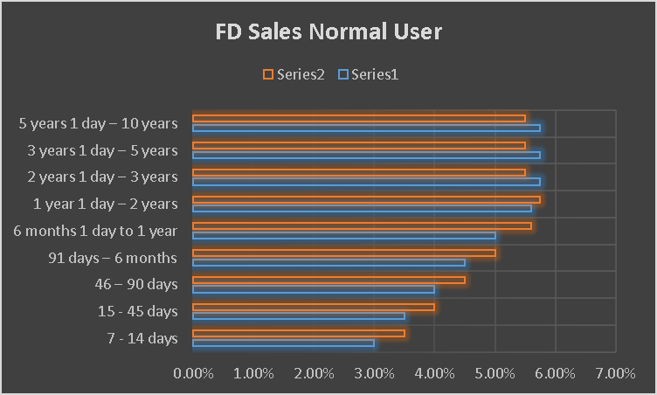

Senior citizens

Task

1. Product code HDH, find the rate for senior citizens for amounts less than 2 crore.

Using vlookup for product code HDH,

Formula= =VLOOKUP(A4,A4:F12,3,TRUE)*100

Product code YFF, find the rate for senior citizens for amounts less than 2 crore.

Using VLOOKUP Formula- =VLOOKUP(A12,A4:G12,3,TRUE)*100